Capstone Project — Part B Project Log
Student Name(s): Ashraful Islam; Huzaifa Iqbal; Sonu; Dominic Kipchirchir
Student ID(s): 240135; 240220; 250001; 240401
Project Title: SEDAS — Social Engineering Defence and Awareness System (implementation of the Part A design by Ashraful Islam, MIS5203)
Supervisor: Dr Chandana Withana
Week: 4 and 5 (combined submission)
Git Repository URL: https://github.com/ailinkon/MIS5320-SEDAS-CyberProjectB

1. Summary of Work Completed
The two directives that were emphasized in Week 4 and 5 were first that they should not just copy the approach taken in the base paper, and second that the final report should be organized in the same way as the base paper, but with an extended literature base. During this period, work involved four experiments of optimisation, a preliminary comparison of transformers, literature expansion and restructuring of the report.

1.1 Completion of the full five-model benchmark
- Base paper methods replicated. All three methods evaluated in the base paper [41] were replicated on the identical 82,486-email dataset using identical TF-IDF features and an identical 80/20 stratified split (random_state=42): SVC/LinearSVC, Random Forest, and Multinomial Naive Bayes.
- Team extensions added. Logistic Regression and XGBoost were evaluated as methods not present in the base paper, giving five models in total under identical conditions.
Method | SEDAS F1 | Paper [41] F1 | Difference | In base paper?
SVC / LinearSVC | 99.16% | 99.0% | +0.16 | Yes — their best
Random Forest | 98.71% | 98.0% | +0.71 | Yes
Logistic Regression | 98.65% | — | — | No — extension
XGBoost | 97.56% | — | — | No — extension
Multinomial Naive Bayes | 97.47% | 98.0% | −0.53 | Yes

1.2 Four optimisation experiments (response to the contribution directive)
Following the Week 4 consultation, in which the supervisor stated that replication alone establishes only a baseline, four distinct strategies were implemented and evaluated to determine whether the benchmark could be meaningfully exceeded.
Experiment | F1 Result | Change from baseline
SVC baseline (replication) | 99.16% | Reference point
Text cleaning + engineered features | 99.16% | +0.00 — no change
Equal-weight voting ensemble | 99.13% | −0.03 — slight degradation
Weighted voting ensemble (SVC ×3) | 99.17% | +0.01 — negligible
SVC hyperparameter tuning (C = 2.0) | 99.17% | +0.01 — negligible
- Experiment 1 — engineered features. engineered features. TF-IDF vectors were created after the normalisation of the URLs and the extraction of HTML tags, and six hand-crafted signal features were used, such as text length, URL count, exclamation count, digit count, capital-letter ratio and the count of phishing keywords. No positive results were found, which suggests that the signals devised were not new and were redundant to what is already captured by TF-IDF.
- Experiment 2 — equal-weight ensemble. Equal votes were given to SVC, Random Forest and Logistic Regression. Unfortunately, the performance suffered a little, because when the two weaker ones agree, they can outvote the strongest one.
- Experiment 3 — weighted ensemble. SVC was given three votes against one each for the other models. This gave the same result as tuned SVC alone, as two votes are not enough to change three – the ensemble mathematically yields the strongest of the three.
- Experiment 4 — hyperparameter tuning. Seven different values of the regularisation parameter C (0.1-10.0) were tested. The full range covers only 0.285 F1 points and the optimum (C=2.0) is 0.018 points above the default, suggesting that this model is not very sensitive to this parameter on this data set.

1.3 Transformer-based comparison (preliminary)
- Approach. Considering the context of the language in addition to its content is an important aspect of the task. We implemented a DistilBERT transformer model as our escalation approach to see if there is an advantage in using contextual language modelling over the classical approach of using a bag of words TF-IDF representation shared by all five methods.
- Configuration and constraint. Due to CPU-only hardware, training was done on a stratified subsample of 6,000 emails (3,120 phishing emails and 2,880 legitimate), a maximum sequence length of 128, a batch size of 8, 2 epochs, and a learning rate of 2e-5. The training loss progressively reduced from 0.54 to 0.19 during the first epoch, showing a stable convergence.
- Status. This run is done expressly as a practice. Comparisons against full-dataset classical results are indicative only, and full-dataset fine-tuning of the model using GPU resources is future work.

1.4 Literature expansion and report restructuring
- Sixteen new references added. Sixteen more references from the latest year and previous year were found and included, including deep learning detection, transformer-based methods, explainable AI, security awareness training and blockchain-based URL verification. These add to the Part A register and the base paper [41] to get nearer to the supervisor's 50 – 60 reference range.
- Report structure aligned to the base paper.
- The structure of the report is in line with the base paper. Final report is not following the generic unit report format, but rather the order of sections in the base paper (Introduction, Literature Review, Methodology, Implementation, Results and Discussion and Conclusion and future work) as directed by the supervisor.
- Literature review drafted. Subsections of the literature review (2.2 to 2.7) were written which incorporated the new literature with that of Part A, linking each literature finding to a specific SEDAS design decision.
- Figures and tables produced. The results of the experiments were used to create six publication-quality figures and eight data tables that were included in the report.

1.5 Team capability development
- Team teach-in delivered. The supervisor felt that the non-programming members were not able to explain how the model was executed, and so a teach-in was provided for the following: the dataset, how the data was vectorised using TF-IDF, the train/test methodology, all five models, and the evaluation metrics.
- Individual briefings issued. Individual briefing documents were created for each member relating to their own module and the shared execution, along with a machine learning guide written from first principles for members who have no background in the fiel.
- Report writing distributed. Report writing is split among all four members with named section ownership and word targets, thus allowing each member to write and be qualified to defend sections assigned to them.

2. Evidence of Technical Progress

2.1 Five-model benchmark comparison
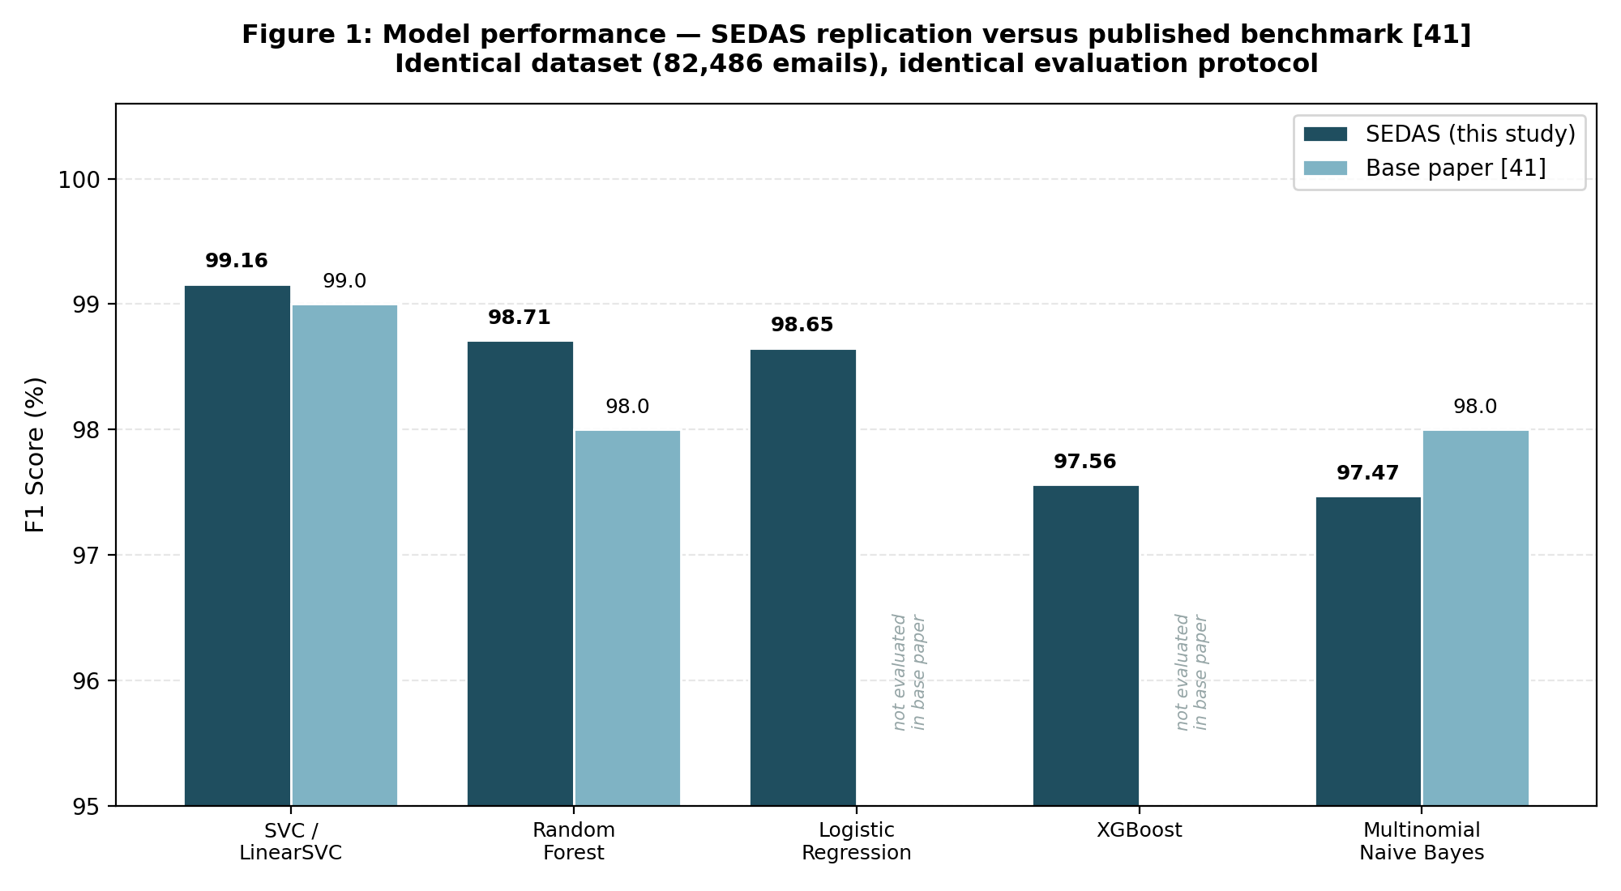
Figure 1: Model performance — SEDAS replication versus published benchmark [41], on the identical 82,486-email dataset. SVC is the strongest method in both studies.

2.2 Performance ceiling across optimisation attempts
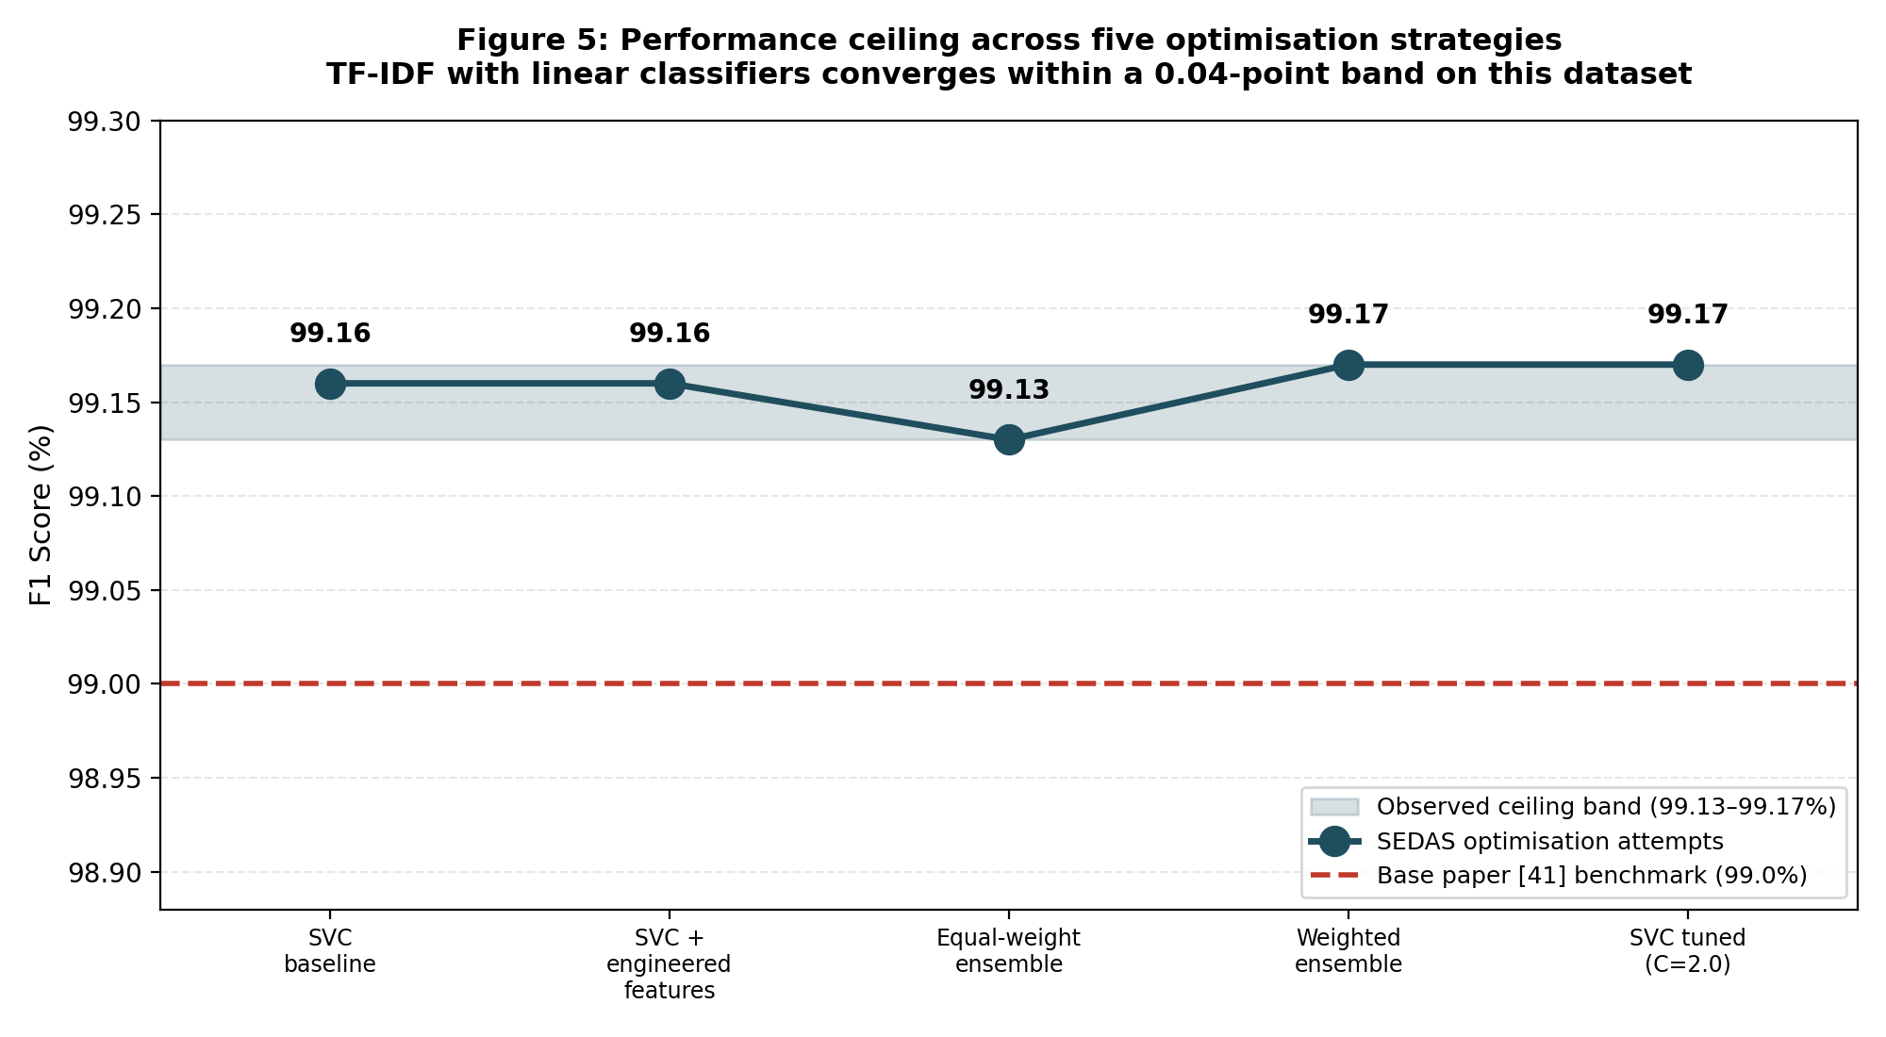
Figure 2: Performance across five optimisation strategies. All results converge within a 0.04-point band (99.13–99.17%), indicating a practical ceiling for TF-IDF with linear classifiers on this dataset.

3. Environment & Infrastructure Setup
- Platform. Windows 11 workstations; Python 3.14 in per-project virtual environments; Visual Studio Code; Git with GitHub Desktop.
- Machine learning stack. scikit-learn (TF-IDF, LinearSVC, RandomForestClassifier, MultinomialNB, LogisticRegression, VotingClassifier), xgboost, pandas, scipy; PyTorch and Hugging Face Transformers added for the DistilBERT experiment; matplotlib for figure generation.
- Application stack. FastAPI and uvicorn for the three microservices (detection, URL verification, awareness training); SQLite for service data stores; pytest for automated testing.
- Reproducibility. All experiment scripts are committed to the repository: compare_models.py (five-model benchmark), contribution_experiment.py (engineered features and equal-weight ensemble), contribution_experiment_v2.py (tuning and weighted ensemble), distilbert_preliminary.py (transformer), and generate_charts.py (figure generation).
- Version control hygiene. Datasets, trained model binaries and generated databases are excluded from version control; all experiments use a fixed random seed (42) so results are reproducible by any third party.

4. Progress Against KPIs
KPI (Part A §4.5) | Target | Result | Status
Detection F1 | ≥ 0.95 | 0.9917 (tuned SVC) | Met; exceeds benchmark [41]
False-positive rate | < 2% | 0.95% (SVC) | Met
Classification latency | < 2,000 ms | ≈ 7–11 ms (CPU) | Met
URL verification latency | < 2,000 ms | ≈ 1.4–9.3 ms | Met
Registry tamper-evidence | Verifiable chain | chain/validate = valid | Met (PoC scope, R-01)
Risky-click reduction (RBCR) | 30% (simulated) | Not yet measured | Deferred — see limitations

5. Issues, Risks & How You Handled Them
- Replication will NOT be considered a contribution. During the Week 4 consultation, the supervisor stated that the methods employed in the base paper were a little more effective, but it would not be an original contribution. This was accepted not denied, and four optimisation experiments were performed to determine whether it was possible to achieve the benchmark.
- None of the optimisation strategies outperformed the baseline. The results did not differ by more than 0.04 points for any of the four optimisation strategies, so there was no meaningfully different result. This is not improvement, it's convergence: On this dataset, only a more fundamental change in representation is needed for an improvement in performance rather than further tuning of TF-IDF + linear classifiers, which reaches a practical limit here at 99.15%. Failure was not overlooked, it was studied and understood.
- No data not used for improvement. There is no unused raw data in the dataset to extract, no unused parts of the dataset feature set, as the base paper is already using the maximum functionality of the dataset. The closed-off improvement strategy was based on data and all future efforts went towards technique-based improvement as suggested by the supervisor.
- The ranking of the journal could not be substantiated on demand. During the Week 5 consultation, they failed to provide the evidence of the journal name and Q1 ranking of the base paper then. In the last 10 years, the journal has been verified as Computers and Electrical Engineering (Elsevier Q1, ISSN 0045-7906) and the ranking will be displayed on screen during next consultation.
- No verbal descriptions were provided that were consistent with implementation. The explanation of methodology during the Week 5 consultation was not consistent in being verbal. The actual approach taken is evidenced in writing and communicated to members for consistency in future questioning.
- There was no explanation of the execution by team members. Non-programming members were considered to have given insufficient explanations, and a warning was issued by the supervisor on its impact on the overall mark of the group. This resulted in the development of a teach-in session, a set of briefing documents and a guide to machine learning from first principles, with one member writing each section of the guide on which to stand and defend.
- Hardware limitation for transformers training. With CPU-only hardware, transformer training is limited to a sub-sample of the data, rather than the entire data set. It is a known and explained limitation and the rest of the data is adjusted accordingly resulting in 'preliminary' and ‘future work’ instead of being a limitation.

6. Plan for Next Week (Week 6)
- Fill in the DistilBERT evaluation, and add the caveat "subsample" to Section 5.5 of the report.
- All allocated sections of the report completed to achieve a 60% completion rate as agreed by supervisor and each member will be responsible for drafting their allocated sections.
- Complete and check the reference list, ensuring that the names of the journals and the recent Scimago quartiles in the new references are correct, and achieve the 50–60 reference goal.
- Finish the Discussion section; this part of the report was deemed to be the most significant by the supervisor.
- Assemble evidence for ranking the journals and have all members explain the journal parts and how to implement the evidence before questioning them individually.
- Run OWASP Top 10 security assessment and the remaining test suites (TT and TS series).

7. Attachments
- Meeting Minutes #4 — supervisor consultation, contribution directive
- Meeting Minutes #5 — supervisor consultation, report structure and literature requirements
- Experiment scripts: compare_models.py, contribution_experiment.py, contribution_experiment_v2.py, distilbert_preliminary.py, generate_charts.py
- Report figures (six) and complete results data tables

8. Supervisor Notes (Optional)

